Access to American Trails Learning Resources through the Kansas Learning Center
Paving the Way Grant Recipient Guide
As a Paving the Way grant recipient, your organization is eligible to receive one year of access to American Trails learning resources through the Kansas Learning Center. Organizations are strongly encouraged to become members of Kansas Trails Inc. (KTI) to maximize the value of this opportunity and strengthen Kansas' statewide trail network. KTI memberships may be purchased using grant funds.
All Paving the Way grantee Organizations will receive one-year access for two individuals to the Kansas Learning Center, powered by American Trails and supported through the Paving the Way program. Through the Kansas Learning Center, participants gain access to a comprehensive library of trail planning, development, management, and advocacy resources, including more than 300 archived webinars, educational tools, professional development opportunities, best practices, and other valuable training resources.
This opportunity is designed to connect trail champions across Kansas with both statewide resources through KTI and nationally recognized trail education and expertise through American Trails, helping support current projects and future trail development efforts.
What's Included?
- Access for two individuals to American Trails learning resources through the Kansas Learning Center
- Connection to a national network of trail leaders and communities
What’s Included if you pair this opportunity with a KTI membership:
For a $100 organizational KTI membership, your organization will receive:
- Membership in Kansas Trails Inc.
- A KTI T-shirt
- Access for two individuals to American Trails learning resources through the Kansas Learning Center
- Connection to a statewide and national network of trail leaders and communities

Step 1: Consider Joining KTI
Organizations are encouraged to complete a $100 organizational (GUIDE) membership with Kansas Trails Inc. to take full advantage of the resources and networking opportunities available through this initiative.
This membership may be paid using your Paving the Way grant funds.

Step 2: Identify Your Two Participants
Select up to two individuals from your organization who will receive access to American Trails learning resources through the Kansas Learning Center.
Be prepared to provide:
- Full name
- Email address
for each participant.

Step 3: Submit Your Contact Information
Provide the names and email addresses of your two designated participants to the Sunflower Foundation at Kmark@sunflowerfoundation.org or to KTI at info@kstrails.org.
If your organization has joined KTI, please indicate that when submitting participant information so staff can ensure you receive all available membership benefits.

Step 4: Watch for Your American Trails Invitation
After registration is completed, Sunflower Foundation will send each participant an American Trails login link. Each time you sign in to your American Trails account, American Trails will send a new login link (no password required).
Step-by-Step: Member Login
Open your web browser and go to:
https://www.americantrails.org/member/member-logout
Enter the email address that KTI registered you with. This must match exactly — double-check for typos before proceeding.
Click the "Request Login Link" button.

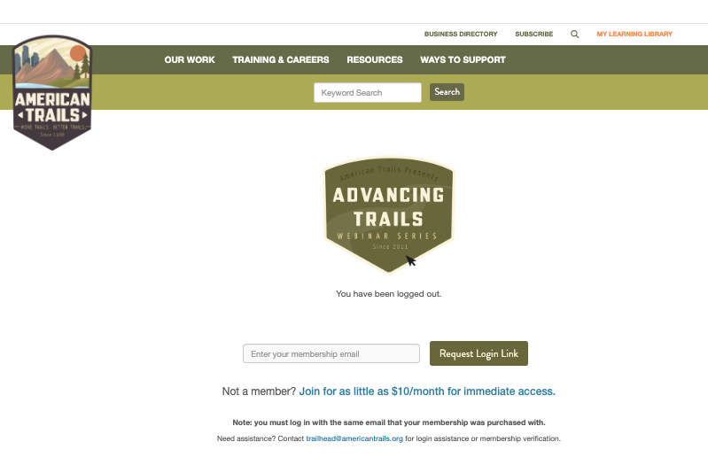

Check your email inbox for a message from American Trails. It will contain a login link — click that link to access your account.

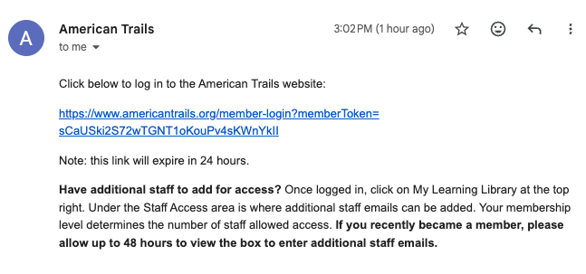
You are now logged in. Bookmark your dashboard page so you can return easily.

Tip: You do not need a password. American Trails uses a login link sent to your email each time you sign in. To avoid having to request a new link each visit, keep your browser tab open while you are working.

